A Four-day Voyage of discovery and experience concerning Roberto Assagioli and Psychosynthesis

Psychosynthesis is a holistic understanding of the human psyche, its makeup, functions, and processes.
Psychosynthesis was developed by Dr. Roberto Assagioli, from a scientific study encompassing Psychology, Philosophy, Religion, Education, and the Arts.
It includes an understanding of the nature, levels and functions of the Unconscious, the level and content of consciousness, the nature of the personal self, or the I, and the Higher or Transpersonal Self.
On this voyage we will address together who am I, what is it to be human? Is there a meaning that we all share in? What are spiritual values, where do they come from, how can we apply them in our life?
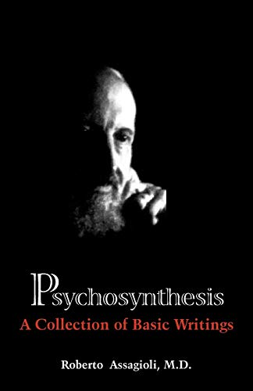
Assagioli’s intent was to take a scientific approach to a broad field of knowledge, including the study of Psychology, Philosophy, Religion, The Arts and Science, Literature, and the field of Education. Included with this understanding regarding the psyche are techniques and methods designed to provide the experience of what is presented.
Night One
Roberto Assagioli, a brief biography, the development of Psychosynthesis.
The “egg diagram”, a graphic representation of the I within the field of consciousness, the levels of the Unconscious, the connection to the Higher Self, and what is beyond our personal sphere of existence.
The stages of Psychosynthesis, the development of a balanced and effective personality, the connection to higher values and the higher Self.
Night Two
Psychosynthesis understands the will as the primary function by which we act in the world.
Assagioli’s contribution was to understand the different ways the will can be utilized; the Strong Will, The Skillful Will, The Good Will.
Also presented are the seven stages that take place in the planning and carrying out of an act of will.
Night Three
A focused consideration of what is meant by the Higher Self and spiritual values, where do they come from, how can they be developed?
Night Four
The 7 core concepts that Assagioli believed to be an essential part of training for anyone at the Psychosynthesis Institutes.
They can also serve as a review and focus for the understanding of Psychosynthesis, and what it offers.
The primary text for Psychosynthesis was first published in 1965.
Current edition is Psychosynthesis: A Collection of Basic Writings.
Additional books by Dr. Assagioli are:
The Act of Will, and a posthumous publication, Transpersonal Development: The Dimension Beyond Psychosynthesis

